***PIZZA SALES SQL QUERIES***

1. KPI’s
2. **Total Revenue**

select sum(total_price) as Total_Revenue from [Pizza DB].dbo.pizza_sales

***Output:***

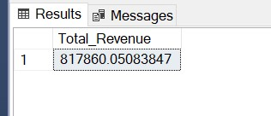

1. **Average Order Value**

Select (sum(total_price)/count(DISTINCT order_id)) as Avg_order_value from [Pizza DB].dbo.pizza_sales

***Output:***

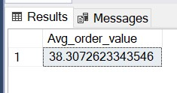

1. **Total Pizza sold**

select sum(quantity) as Total_pizza_sold from pizza_sales

***Output:***

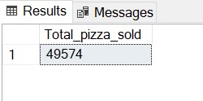

1. **Total Orders**

select count(DISTINCT order_id) as Total_Orders from pizza_sales

***Output:***

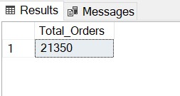

1. **Average Pizzas per order**

select cast(sum(quantity) as decimal(10,2))/cast(count(DISTINCT order_id) as decimal(10,2)) as Average_pizzas_per_order from pizza_sales

***Output:***

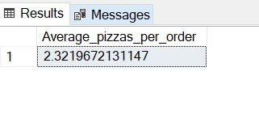

1. **Daily Trend for Total Orders**

SELECT DATENAME(DW, order_date) AS order_day, COUNT(DISTINCT order_id) AS total_orders

FROM pizza_sales

GROUP BY DATENAME(DW, order_date)

***Output:***

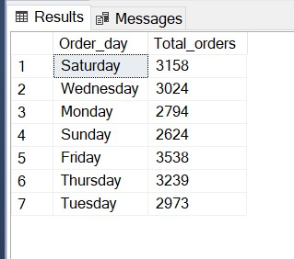

1. **Monthly Trend for Orders**

select DATENAME(MONTH, order_date) as Month_Name, COUNT(DISTINCT order_id) as Total_Orders

from pizza_sales

GROUP BY DATENAME(MONTH, order_date)

***Output:***

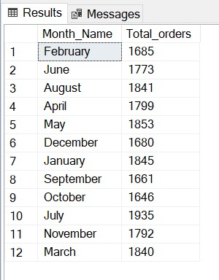

1. **% of Sales by Pizza Category**

select pizza_category, sum(total_price)*100 / (select sum(total_price) from pizza_sales)

as Percentage_of_total_sales from pizza_sales

group by pizza_category

***Output:***

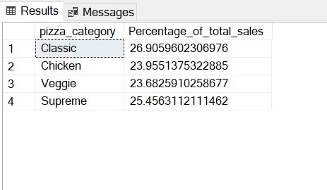

1. **% of Sales by Pizza Size**

select pizza_size, cast(sum(total_price) as decimal(10,2)) as total_revenue ,

cast(sum(total_price)*100/(select sum(total_price) from pizza_sales) as decimal(10,2))

as PCT from pizza_sales

group by pizza_size

order by pizza_size

***Output:***

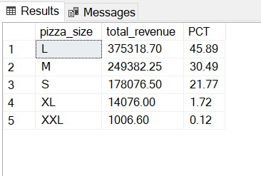

1. **Total Pizzas Sold by Pizza Category**

select pizza_category, sum(quantity) as total_quantity_sold

from pizza_sales

-- where MONTH(order_date) = 1

group by pizza_category

order by total_quantity_sold

desc

***Output:***

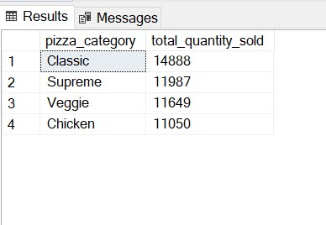

**G. Top 5 Pizzas by Revenue**

select top 5 pizza_name , sum(total_price) as Total_revenue from pizza_sales

group by pizza_name

order by Total_revenue

desc

***Output:***

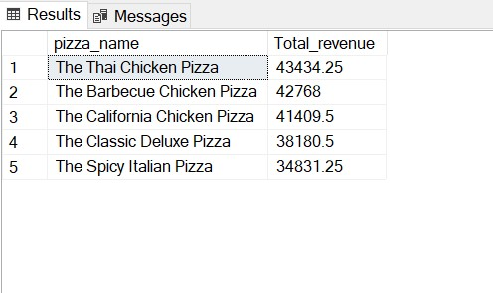

1. **Bottom 5 Pizzas by Revenue**

select top 5 pizza_name , sum(total_price) as Total_revenue from pizza_sales

group by pizza_name

order by Total_revenue

asc

***Output:***

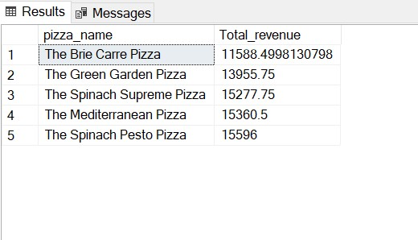

1. **Top 5 Pizzas by Quantity**

SELECT Top 5 pizza_name, SUM(quantity) AS Total_Pizza_Sold

FROM pizza_sales

GROUP BY pizza_name

ORDER BY Total_Pizza_Sold DESC

***Output***

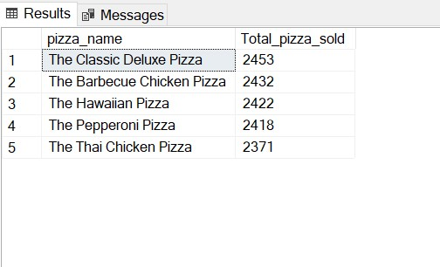

1. **Bottom 5 Pizzas by Quantity**

SELECT TOP 5 pizza_name, SUM(quantity) AS Total_Pizza_Sold

FROM pizza_sales

GROUP BY pizza_name

ORDER BY Total_Pizza_Sold ASC

***Output***

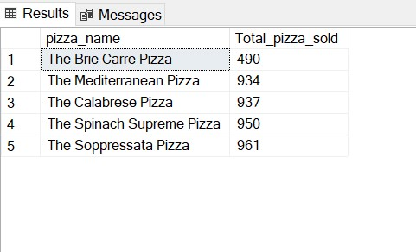

1. **Top 5 Pizzas by Total Orders**

SELECT Top 5 pizza_name, COUNT(DISTINCT order_id) AS Total_Orders

FROM pizza_sales

GROUP BY pizza_name

ORDER BY Total_Orders DESC

***Output***

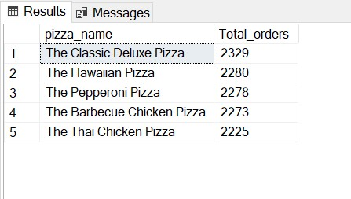

1. **Borrom 5 Pizzas by Total Orders**

SELECT Top 5 pizza_name, COUNT(DISTINCT order_id) AS Total_Orders

FROM pizza_sales

GROUP BY pizza_name

ORDER BY Total_Orders ASC

***Output***

